- What is your research question?
What linguistic features are predictors of misinformation on social media?
Do these features differ across sources?
Can user responses styles (i.e. sentiment of comments) predict real and fake news?
- Who would like to know the answer to this question?
Social scientists studying misinformation, media ecosystems, and platform effects on political and social communication; NLP researchers on fake news/clickbait detection; journalists/fact-checking organizations; platform moderators/consumers who frequently engage with large amount of information on social media.
3. What data are you using?: https://arxiv.org/abs/2403.09092 (MCFEND: A Multi-source Benchmark Dataset for Chinese Fake News Detection)
- How is it sampled?
  - Web-crawling from active Chinese fact-checking agencies
  - cross-lingual identical news retrieval to obtain corresponding Chinese equivalents of both real and fake English news within several English fake-news datasets. The sources were then translated, calculated for news similarity (with Pearson correlation), and labeled.
  - Weibo news collection from Weibo-21 dataset (largest Chinese fake news detection dataset on Weibo
    - For Weibo posts, user responses such as comments, reposts, and likes were also collected.
- How large is it?
  - 23,789 news pieces
  - Social context data: 170,713 posts and 2,102,902 comments from 803,779 distinct users
- Who collected it?
  - Researchers collected news sourced from 14 different fact-checking agencies in both English and Chinese.
- What are the main variables of interest?
  - Multi-modal news content, including text, images, metadata, e.g., timestamps;
  - Multi-modal social context, including posts, comments, emojis, user profiles, and other metadata, e.g., like counts of comments.
- How were these variables obtained?
  - Web-crawling, text cleaning, deduplication, and label-mapping.
- Describe these variables statistically with appropriate descriptives
  - 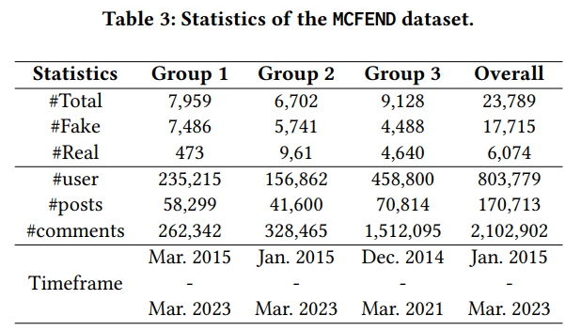
  - *group 1: Chinese fact-checking agencies
  - *group 2: English fact-checking agencies
  - *group 3: Weibo Community Management Center (from which news data was sourced from Weibo-21
- Are there any potential issues with the data?
  - Sampling bias – the dataset is not randomly sampled, hence the misinformation selected may have a different distribution/concentration compared to the natural state of news circulation online.
  - Does not distinguish levels of misinformation (errors in fact-reporting vs. fear-mongering, engagement-baiting, etc.)

